**2. Implement programs for visualizing time series data**

**AIM:**

To implement programs for visualizing time series data

**PROCEDURE:**

1. **Import the necessary libraries:**

from google.colab import files

uploaded = files.upload()

import pandas as pd

1. **Load the dataset:**

import io

df = pd.read_csv(io.BytesIO(uploaded["autism.csv"]))

print(df)

1. **Implementing program for visualising time series data using scatter plot.**

import matplotlib.pyplot as plt

import seaborn as sns

plt.figure(figsize=(10, 6))

plt.scatter(df['age'], df['result'])

plt.xlabel('age')

plt.ylabel('result')

plt.title('Scatter Plot of Time Series Data')

plt.show()

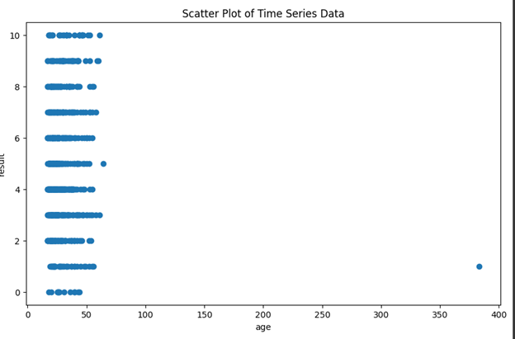

**4. Implementing program for visualising time series data using area plot.**

plt.figure(figsize=(10, 6))

plt.stackplot(df['age'], df['result'])

plt.xlabel('age')

plt.ylabel('result')

plt.title('Area Plot of Time Series Data')

plt.show()

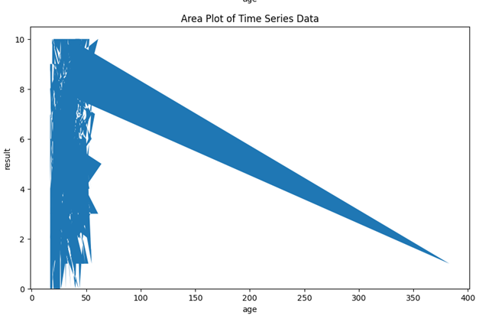

**5. Implementing program for visualising time series data using line plot.**

plt.figure(figsize=(10, 6))

plt.plot(df['age'], df['result'])

plt.xlabel('age')

plt.ylabel('result')

plt.title('Line Plot of Time Series Data')

plt.show()

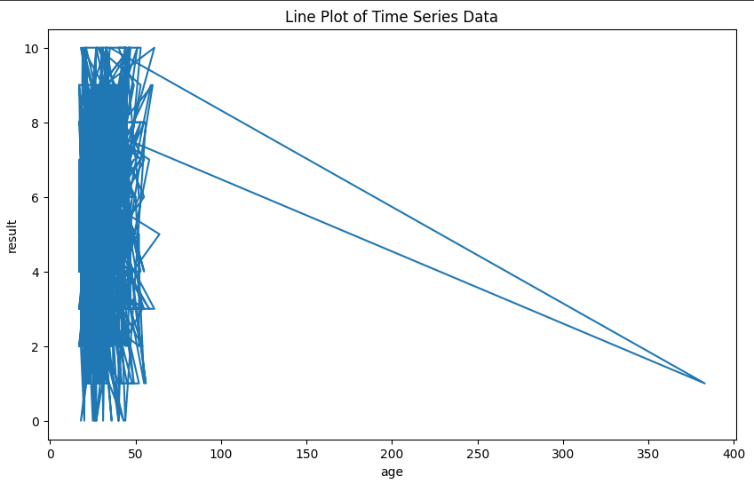

**6. Implementing program for visualising time series data using box plot.**

plt.figure(figsize=(10,6))

sns.boxplot(x=df['age'], y=df['result'])

plt.xlabel('age')

plt.ylabel('result')

plt.title('Box Plot of Time Series Data')

plt.show()

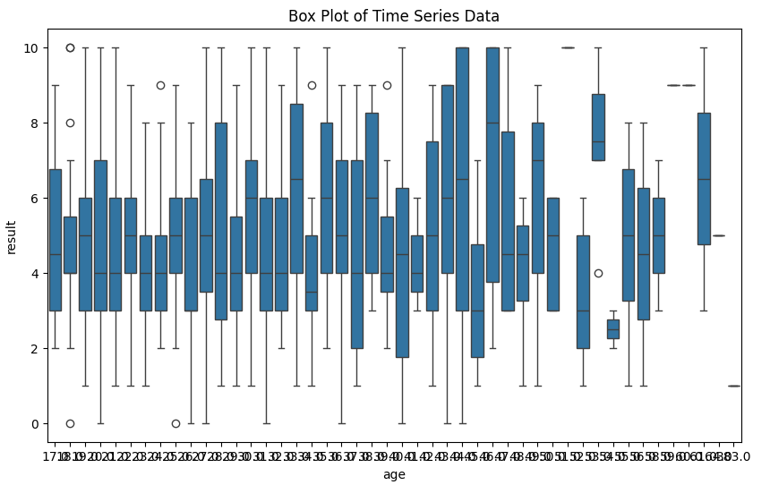

**7. Implementing program for visualising time series data using bar plot.**

plt.figure(figsize=(10, 6))

*# Replace 'A1' and 'A2' with the correct column names from your DataFrame*

plt.bar(df['age'], df['result'])

plt.xlabel('age')

plt.ylabel('result')

plt.title('Bar Plot of Time Series Data')

plt.show()

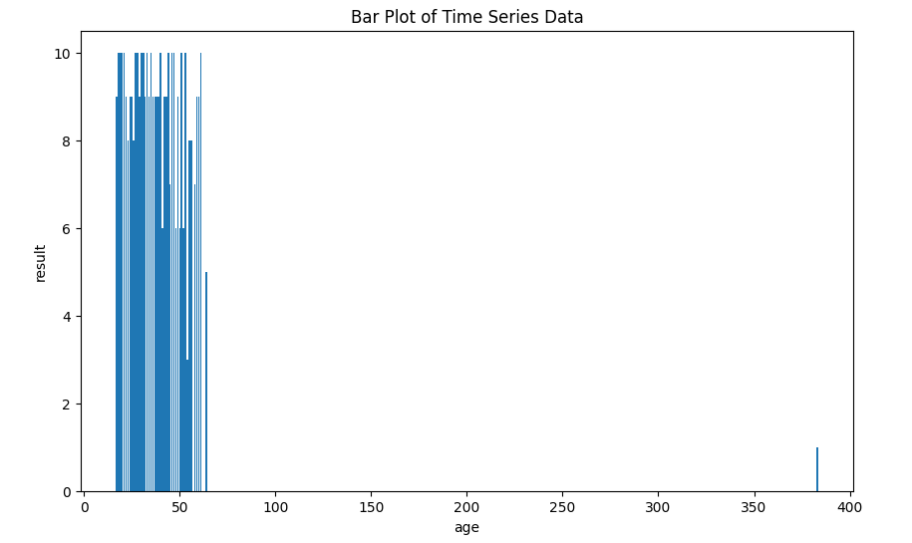

**RESULT:**

The programs for implementing for visualizing time series data is verified successfully.